Project Planning Phase
Project Planning Template (Product Backlog, Sprint Planning, Stories, Story Points)
Date | 13 July 2026
Team ID
Project Name | Visualizing Housing Market Trends: An Analysis of Sale Prices and Features using Tableau
Maximum Marks | 5 Marks
Product Backlog, Sprint Schedule, and Estimation (4 Marks)
Use the below template to create product backlog and sprint schedule.
Sprint | Functional Requirement (Epic) | User Story Number | User Story / Task | Story Points | Priority | Team Members
Sprint-1 | Data Collection & Preparation | USN-1 | Collect housing sales dataset (sale price, bedrooms, bathrooms, living area, lot area, floors, age, renovation status, waterfront view, zipcode group). | 3 | High | Masa Nani
Sprint-1 |  | USN-2 | Clean and standardise raw data, handling missing or inconsistent values. | 5 | High | Masa Nani
Sprint-1 |  | USN-3 | Prepare and transform data (price bins, zipcode grouping, renovation flags, age buckets). | 5 | High | Masa Nani
Sprint-1 |  | USN-4 | Validate the cleaned and transformed dataset. | 3 | Medium | Gabbi Nithya Sree
Sprint-2 | Tableau Dashboard | USN-5 | Build KPI dashboard (total properties, average sale price, total living/basement area). | 5 | High | Masa Nani
Sprint-2 |  | USN-6 | Price & feature relationship analysis (bedrooms, bathrooms, living area vs. sale price). | 5 | High | Gabbi Nithya Sree
Sprint-2 |  | USN-7 | Overall grade / condition vs. sale price comparison. | 3 | High | Gabbi Nithya Sree
Sprint-2 |  | USN-8 | Build interactive filters (zipcode group, bedrooms, bathrooms, price range). | 3 | Medium | Masa Nani
Sprint-3 | Insights | USN-9 | Renovation impact analysis (sales by years since renovation, age by renovation status). | 5 | High | Gabbi Nithya Sree
Sprint-3 |  | USN-10 | House-age distribution analysis by bedrooms, bathrooms and floors. | 5 | Medium | Masa Nani
Sprint-3 |  | USN-11 | Location-wise price analysis by zipcode group. | 3 | High | Gabbi Nithya Sree
Sprint-3 |  | USN-12 | Waterfront & view premium analysis. | 3 | Medium | Masa Nani
Sprint-4 | Deployment | USN-13 | Build guided Tableau Story narrating key housing-market insights. | 5 | High | Gabbi Nithya Sree
Sprint-4 |  | USN-14 | Publish dashboard and story to Tableau Public. | 3 | High | Masa Nani
Sprint-4 |  | USN-15 | Testing (verify dashboard accuracy, filter behaviour and story flow). | 3 | High | Gabbi Nithya Sree
Sprint-4 |  | USN-16 | Documentation. | 2 | High | Masa Nani
Project Tracker, Velocity & Burndown Chart: (4 Marks)
Sprint | Total Story Points | Duration | Sprint Start Date | Sprint End Date (Planned) | Story Points Completed (as on Planned End Date) | Sprint Release Date (Actual)
Sprint-1 | 16 | 7 Days | 20 Jul 2026 | 26 Jul 2026 | 16 | 26 Jul 2026
Sprint-2 | 16 | 7 Days | 27 Jul 2026 | 02 Aug 2026 | 16 | 02 Aug 2026
Sprint-3 | 16 | 7 Days | 03 Aug 2026 | 09 Aug 2026 | 16 | 09 Aug 2026
Sprint-4 | 13 | 7 Days | 10 Aug 2026 | 16 Aug 2026 | 13 | 16 Aug 2026
Velocity:
Imagine we have a 10-day sprint duration, and the velocity of the team is 20 (points per sprint). Let’s calculate the team’s average velocity (AV) per iteration unit (story points per day).
AV = sprint duration / velocity = 20 / 10 = 2
For this project, across the 4 sprints, the team completed a total of 61 story points.
Velocity: 61 / 4 = 15.25 story points per sprint.
Burndown Chart:
A burn down chart is a graphical representation of work left to do versus time. It is often used in agile software development methodologies such as Scrum. However, burn down charts can be applied to any project containing measurable progress over time.
https://www.visual-paradigm.com/scrum/scrum-burndown-chart/
https://www.atlassian.com/agile/tutorials/burndown-charts

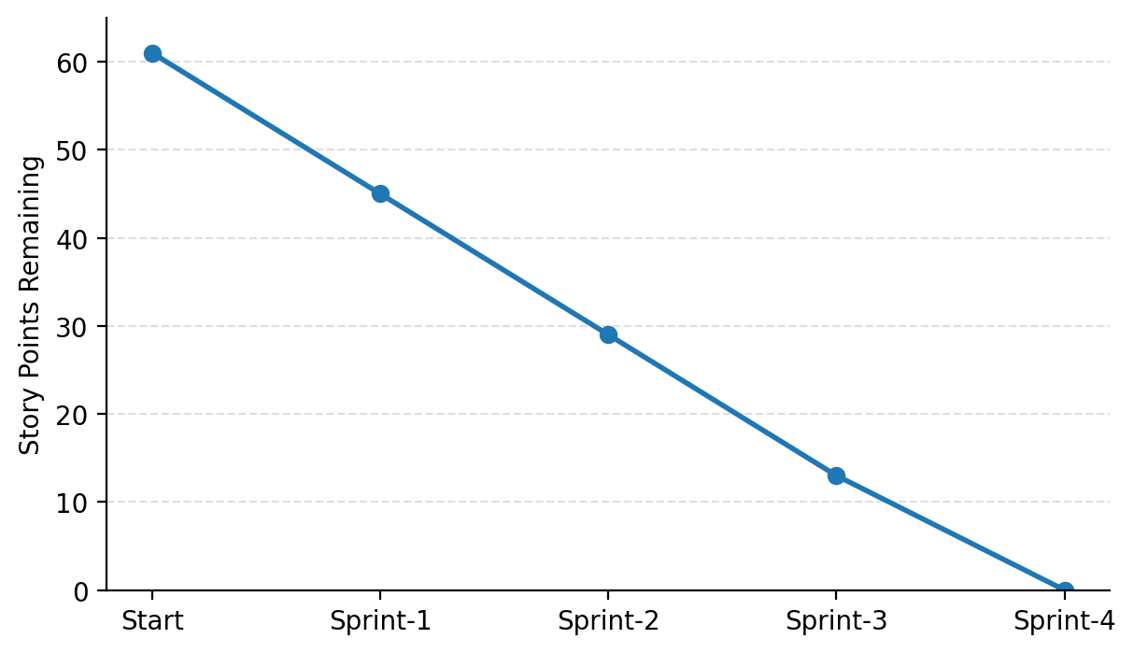
Reference:
https://www.atlassian.com/agile/project-management
https://www.atlassian.com/agile/tutorials/how-to-do-scrum-with-jira-software
https://www.atlassian.com/agile/tutorials/epics
https://www.atlassian.com/agile/tutorials/sprints
https://www.atlassian.com/agile/project-management/estimation
https://www.atlassian.com/agile/tutorials/burndown-charts

